Standard Operating Procedure: .fcs files from cell segmentations

# Introduction:

I’ll keep this short and sweet. .fcs files are outputs from a flow cytometry experiment, and pathologists are used to setting thresholds in software that can read .fcs files. They are no different than .csv files in nature, where each row corresponds to a unique cell/nucleus, and columns correspond to a measurement. The goal is to create .fcs files from cell segmentations on histopathology images

# Generating segmentations in QuPath

Segmentations can be generated by applying a watershed, Stardist, or tile-based segmentation. Alternatively, segmentations generated externally can be loaded in. This SOP will detail how to generate segmentations within QuPath as that is what I’m familiar with. For this manuscript, we will need 2 sets of segmentations, per image, and per segmentation type. One set is segmentations within the crops, the other set is whole slide.

1. Select all crop annotations (ctrl+alt+a). If choosing to process whole image, create a whole image annotation (ctrl+shift+a)
2. Run segmentation within those regions. I’ve used Spleen_reg001_stardist.groovy in the example below. Make sure measurements are included in these detections. May have to add them afterwards if using an external segmentation.

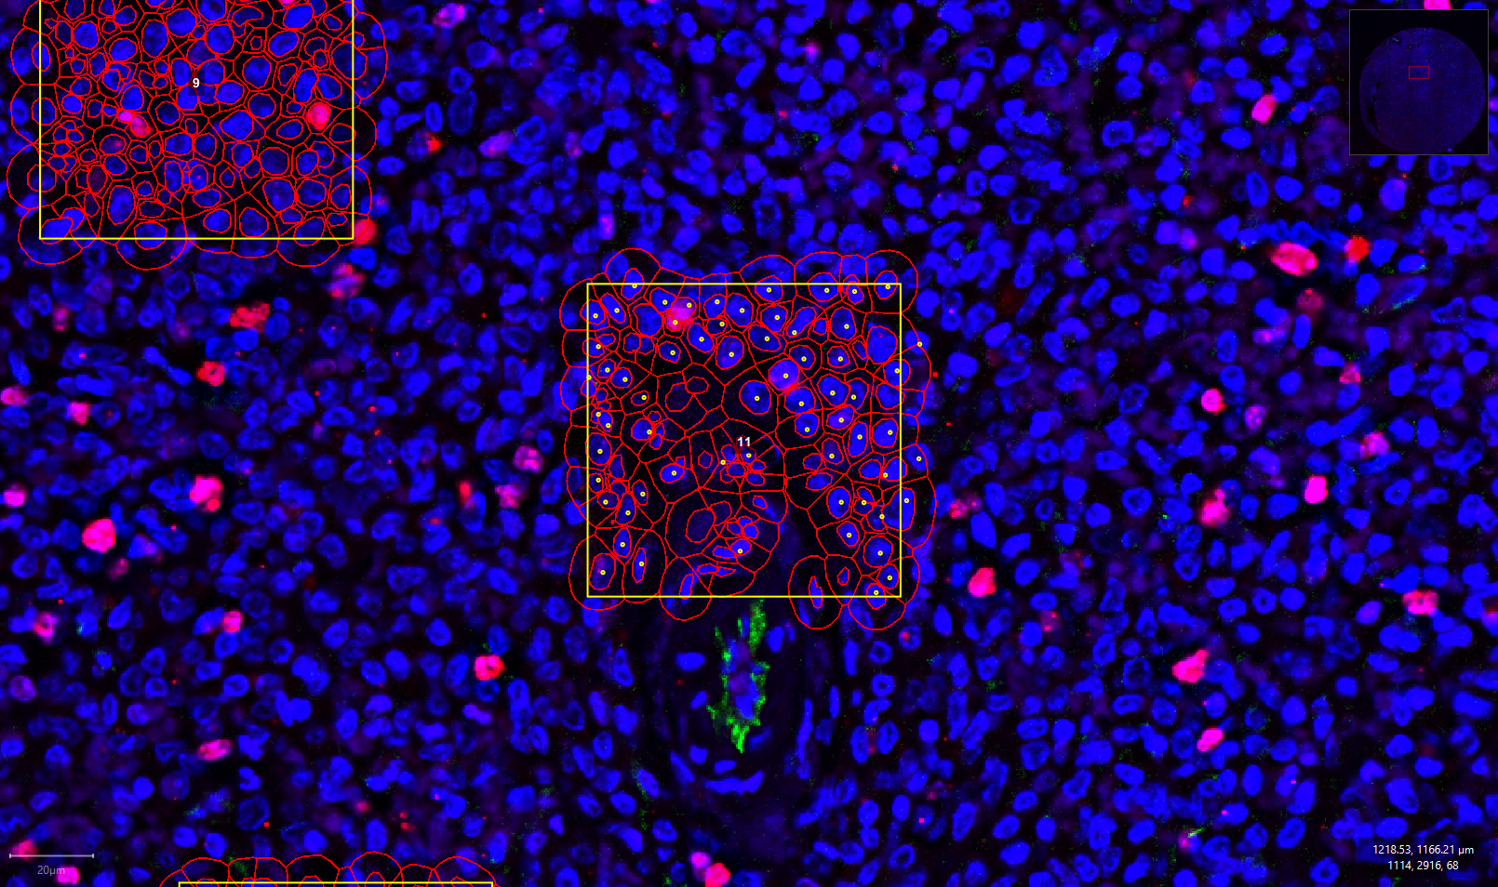

# Exporting and formatting per-cell statistics

1. **Save the project to update with new detections (ctrl+s). I cannot stress this enough.**
2. Export measurements
   1. Export type – cells
   2. Separator – comma (.csv)
   3. Set name using the following nomenclature: project_image_segmentation_region.csv (e.g. spleen_reg001_stardist_crops.csv)
3. Next, we need to remove any : from the file, as this can lead to errors during the conversion to .fcs. This can either be done manually (open the csv, do ctrl+f, find and replace : with _) or using this python script: csv_pruner.py

# Convert .csv to .fcs

1. Create a free account on GenePattern (<https://cloud.genepattern.org/gp/pages/index.jsf>)
2. Select the CsvToFcs module
3. Upload the .csv file and run (default parameters are fine)
4. Processing should take ~2 minutes, after which you can download the .fcs file
5. (optional) view the .fcs file to see if it processed correctly

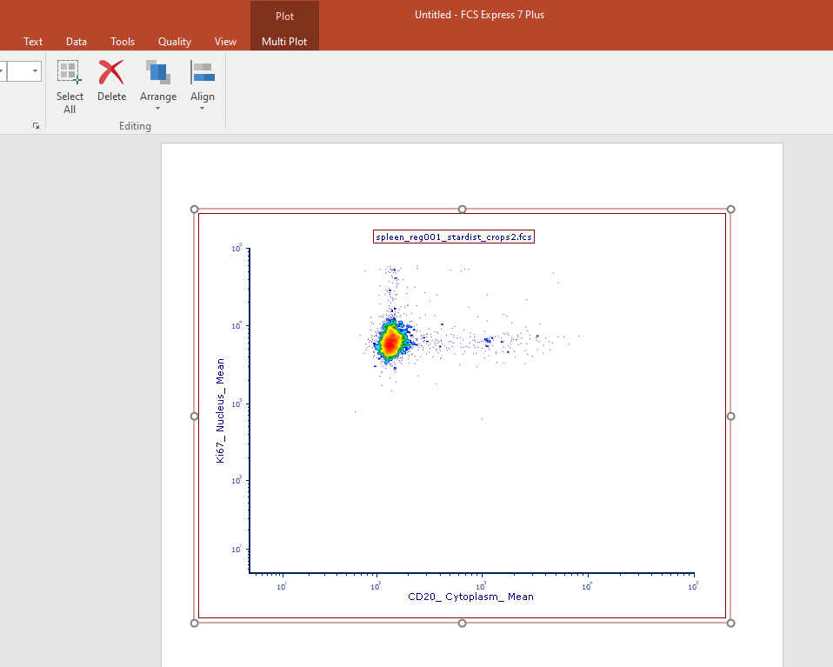

1. Repeat the entire pipeline from step 1 of ‘Generating segmentations in QuPath’, varying the region (whole slide or crops), tissue, and segmentation type